Lionfish Methods

*Hydrodynamic Model Details*

To investigate hypothesis that the spread of *Pterois miles* in the Mediterranean was primarily driven by passive dispersal of larvae following an initial introduction, particle tracking experiments were run using an offline Lagrangian particle tracking model, PARCELS “Probably A Really Computationally Efficient Lagrangian Simulator” (Delandmeter & Van Sebille, 2019; Lange & Van Sebille, 2017), described below. These simulations used daily velocity fields from the Mediterranean Sea Analysis and Forecast product MEDSEA_MULTIYEAR_PHY_006_004 (Escudier et al 2020) and MEDSEA_ANALYSIS_FORECAST_PHY_006_013 (Clementi et al 2019). These products are both high resolution data-assimilating coupled hydrodynamic-wave modelling systems implemented over the whole Mediterranean Basin with horizontal resolution of 1/24° (approximately 4km) and 141 vertically unevenly spaced levels. MEDSEA_MULTIYEAR_PHY_006_004 is a reanalysis spanning 1987 – 2019 while MEDSEA_ANALYSIS_FORECAST_PHY_006_013 is the analysis and forecast product spanning 2017-present (2021). We only used MEDSEA_ANALYSIS_FORECAST_PHY_006_013 velocity fields for 2019 and 2020.

*Particle Characteristics and Experimental Design*

The Lagrangian particle simulations were conducted using PARCELS v2.0.2 which is an open-source framework for simulating Lagrangian particle trajectories, designed to efficiently process large amounts of data (Delandmeter & Van Sebille, 2019; Lange & Van Sebille, 2017). Dispersal simulations were conducted using only velocity data from the 29.88m depth layer of the hydrodynamic models which aligns with the depth which lionfish larvae are most observed (30m; Sponaugle et al 2019).

Lionfish are known to have limited spawning year-round with a peak in spawning activity (Savva et al 2020). To simulate this in our modelling process, we released 40 times more particles during the May – July, compared to the rest of the year. As Lionfish larvae are known to be poor swimmers (Johnson et al 2016), no active behaviour was included in the simulations and all dispersal was driven by ocean currents. A small amount of Brownian motion (10 m2 s-1) used to add variation to particles released on the same day in the same location. Larvae were tracked for 26 days post spawning to match the mean settlement date of the closely related Lionfish *P. volitans* (Ahrenholz & Morris 2010). Dispersal was assumed to be successful if after 26 days they were in areas with a bathymetry shallower than 350 m, particles which did not settle successfully were defined as dispersal mortalities. As there was no variation in pelagic larval duration in our simulations there was no need to apply a mortality rate during the simulations beyond the dispersal mortality.

To simulate the maximum potential spread of *Pterois miles* in the Mediterranean Sea due to larval dispersal we ran simulations of larval dispersal based upon the first confirmed observations of Lionfish which became established. These were two observations in Lebanon from 2012, both at 34.49° N, 35.91° E (Dimitriadis et al. 2020). Particles were released from this location every day from 1st January 2012 to 31st December 2012 with 80 particles released per day during the peak spawning period (May – July) and 2 particles released every other day (Figure 1). Particles which successfully settled from this dispersal event were then used for similar simulations in following years. Due to computational limitations, in each year in the simulation, the 1000 western-most successful settlement locations were used to release particles. While this biases overall larvae settlement distributions in subsequent years, it aligns with our aim of modelling maximum dispersal potential assuming spawning locations further west will disperse larvae further west.

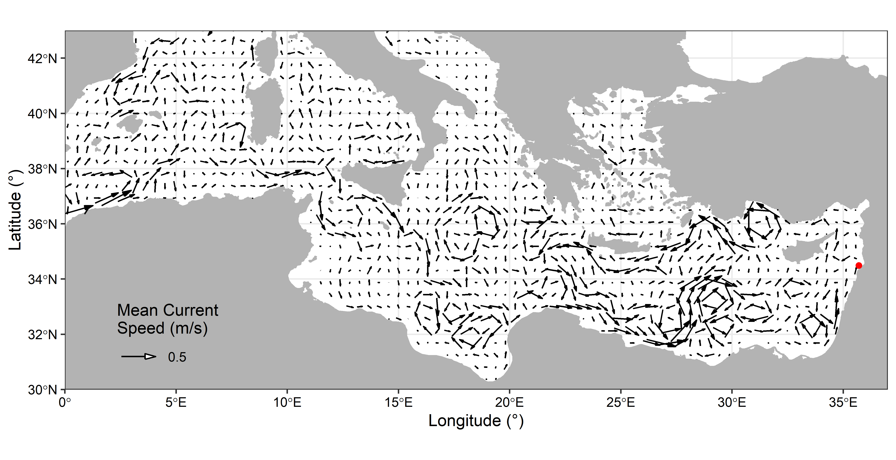

**Figure 1** Mean currents at 29.88m depth in the Mediterranean Sea during May-July (the main spawning period for Lionfish) 2012. The red dot represents the original release location for our dispersal simulations based upon the observed sighting of Lionfish reported by Dimitriadis et al. (2020).

**Results**

Based upon the simulations of larval dispersal based upon a single introduction in on the eastern border of the Mediterranean, the larvae first dispersed north before spreading west. Within the 1st year lionfish were estimated to reach the northwest Mediterranean and two years after introduction the began to spread west. The westward expansion slowed through the more hydrodynamically complex area around 25°E. In 2016, our simulations showed a small number of larvae settling on the southern shore which later established into a larger colony between about 22 and 26°E. In 2019 and 2020.

Figure1: Simulated predicted lionfish settlement sites based upon passive dispersal.

There was high agreement between the predicted passive dispersal and observed lionfish dispersal. The rate and direction of spread in our simulations was consistent with observed lionfish. There were some differences in our simulations and the observed lionfish. It was observed that lionfish were observed XXX (left of map) early than our model predicted. Our model also predicted a larger spread to the north which was not seen in the observed data.

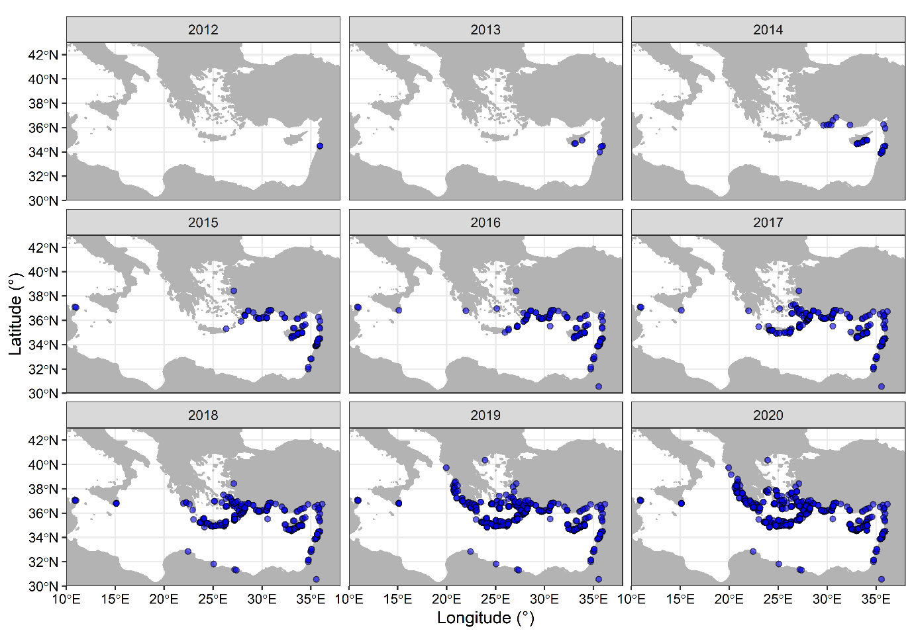

Figure: Observations of Lionfish in the Mediterranean as reported by XXXX. Each dot represents an observation and is present from the year it was observed through to 2020.

**Discussion Notes**

the northern extent in our model is likely is not realistic due to temperature limits this model did not include.

The observations not matching our predictions could be a different form of spread (shipping?).

Overall our simulations match pretty well – therefore most of the spread of lionfish can be explained by larval dispersal.

**References**

Clementi, E., Pistoia, J., Escudier, R., Delrosso, D., Drudi, M., Grandi, A.,Lecci R., Cretí S., Ciliberti S., Coppini G., Masina S., Pinardi, N. (2019). Mediterranean Sea Analysis and Forecast (CMEMS MED-Currents, EAS5 system) [Data set]. Copernicus Monitoring Environment Marine Service (CMEMS).

Escudier, R., Clementi, E., Omar, M., Cipollone, A., Pistoia, J., Aydogdu, A., Drudi, M., Grandi, A., Lyubartsev, V., Lecci, R., Cretí, S., Masina, S., Coppini, G., & Pinardi, N. (2020). Mediterranean Sea Physical Reanalysis (CMEMS MED-Currents) (Version 1) [Data set]. Copernicus Monitoring Environment Marine Service (CMEMS). <https://doi.org/10.25423/CMCC/MEDSEA_MULTIYEAR_PHY_006_004_E3R1>

Ahrenholz, D. W., & Morris, J. A. (2010). Larval duration of the lionfish, Pterois volitans along the Bahamian Archipelago. Environmental biology of fishes, 88(4), 305-309.

Savva, I., Chartosia, N., Antoniou, C., Kleitou, P., Georgiou, A., Stern, N., ... & Kletou, D. (2020). They are here to stay: the biology and ecology of lionfish (Pterois miles) in the Mediterranean Sea. Journal of Fish Biology.

Johnson, J., Bird, C. E., Johnston, M. A., Fogg, A. Q., & Hogan, J. D. (2016). Regional genetic structure and genetic founder effects in the invasive lionfish: comparing the Gulf of Mexico, Caribbean and North Atlantic. Marine Biology, 163(10), 216.